MAINTENANCE SCHEDULE SYSTEM
@CREATIVITY THINK (9483175986/7019689991)

ABSTRACT:
The Maintenance Schedule System is a web-based application designed to automate the planning, tracking, and analysis of maintenance activities for equipment and areas. It provides a centralized platform where users can set recurring maintenance schedules, log task completion, receive reminders, and monitor maintenance performance through dashboards. Administrators can manage equipment data, oversee maintenance tasks, review logs, and generate analytical reports for operational improvements. Developed using Django and Django Rest Framework for the backend and React with axios and recharts for the frontend, the system ensures reliability, transparency, and efficient maintenance workflow management..

INTRODUCTION OF THE PROJECT:
Large organizations such as factories, offices, and residential communities often rely on manual spreadsheets or paper-based workflows for scheduling maintenance. These outdated methods lack reminders, consistency, tracking, and analytics, resulting in delayed maintenance and operational inefficiencies. The Maintenance Schedule System provides a digital solution that automates maintenance planning, prevents missed tasks, and centralizes all activity logs. With dashboards, reminders, and structured scheduling features, it enhances safety, reduces downtime, and ensures smooth operational workflows for both users and administrators..

PROJECT OBJECTIVES:

• Create a centralized platform for scheduling recurring maintenance tasks
• Maintain a database of equipment, areas, and maintenance items
• Allow users to log task completion with date and remarks
• Send reminders and alerts for upcoming or overdue tasks
• Provide dashboard analytics for maintenance performance
• Allow administrators to review logs and export reports
• Improve operational efficiency by reducing missed maintenance
• Support scalable and secure backend APIs for all operations

PROBLEM OF THE STATEMENT:
Organizations using traditional maintenance tracking methods face issues such as missed schedules, poor record-keeping, and lack of visibility into recurring tasks. Without automated reminders and logs, maintenance activities may be delayed, resulting in equipment breakdowns and operational risks. The Maintenance Schedule System solves these challenges by offering automated scheduling, reminders, structured logs, dashboards, and administrative controls, ensuring timely and efficient maintenance..

MOTIVATION OF THE PROJECT:
• To replace manual spreadsheets with an automated maintenance system
• To eliminate missed schedules through timely reminders
• To maintain accurate logs for audits and compliance
• To enhance visibility into equipment condition and maintenance status
• To support preventive maintenance and reduce downtime
• To provide dashboards for analyzing maintenance performance
• To streamline workflows for organizations with multiple maintenance points

BLOCK DAIGRAM OF PROJECT:

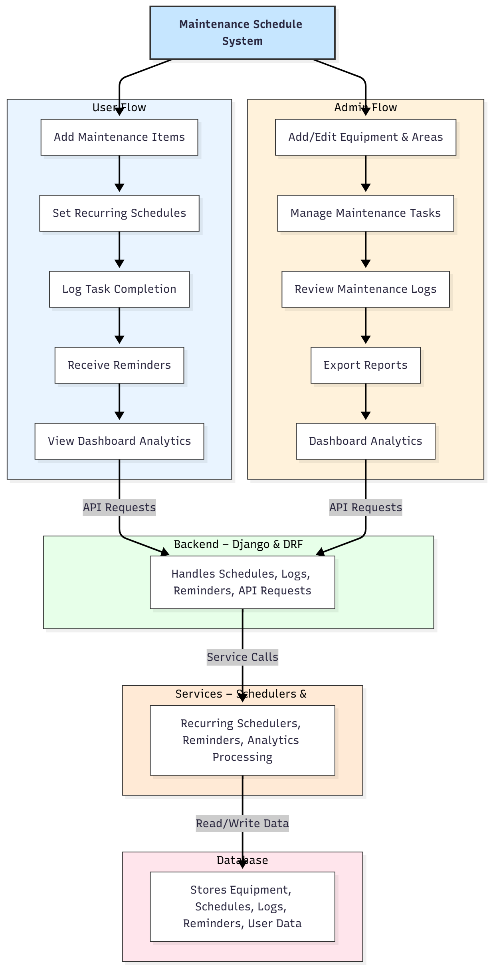

WORKING OF THE PROJECT:
The workflow begins when users or administrators add equipment or area entries that require routine maintenance. Users schedule recurring tasks such as weekly, monthly, or quarterly checks. The backend processes these schedules, triggers reminders through internal scheduling services, and updates task status when users log completion. Administrators monitor all logs, verify completed tasks, manage upcoming tasks, and generate reports. Dashboard analytics provide insights into overdue tasks, completion rates, and maintenance trends. The system ensures a fully digital and structured workflow for maintenance operations..

SOFTWARE REQUIREMENT:
- Backend:
  - Python 3.x
  - Django
  - Django REST Framework
  - SQLite/PostgreSQL
- Frontend:
  - Node.js and npm
  - React.js
  - Axios
- Development Tools:
  - Visual Studio Code
  - Postman (for testing APIs)
  - Git/GitHub (for version control)
- Server/Deployment (Optional):
  - Gunicorn, Nginx, or Heroku/AWS for hosting

ADVANTAGES OF THE PROJECT:

• Prevents missed maintenance tasks through automated reminders
• Centralized equipment and area database
• Provides complete task logs for audits and compliance
• Dashboard insights improve planning and maintenance efficiency
• Reduces equipment failures through preventive maintenance
• Enhances transparency for both users and administrators
• Scalable and suitable for large organizations
• Improves operational reliability and safety

APPLICATIONS OF THE PROJECT:
• Factories and industrial plants
• Corporate offices
• Residential apartments and societies
• Hospitals and healthcare facilities
• Educational institutions
• Facility management companies

REFERENCES:

- Django REST Framework Documentation — Django Software Foundation. Django Documentation. Available: https://docs.djangoproject.com/
- Django REST Framework. DRF Documentation. Available: https://www.django-rest-framework.org/
- React. React Official Documentation. Available: https://reactjs.org/docs/getting-started.html
- Redux. Redux Documentation. Available: https://redux.js.org/introduction/getting-started
- PostgreSQL Global Development Group. PostgreSQL Documentation. Available: https://www.postgresql.org/docs/
- MySQL. MySQL Reference Manual. Available: https://dev.mysql.com/doc/
- Git. Git Documentation. Available: https://git-scm.com/doc
- Node.js. Node.js Documentation. Available: https://nodejs.org/en/docs/
- Axios. Axios Documentation. Available: https://axios-http.com/docs/intro
- Socket.io Documentation – https://socket.io/docs/

